**Lesotho country profile**

Published

8 June

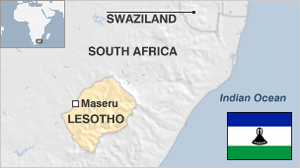

**The Kingdom of Lesotho is made up mostly of highlands, where many of the villages can be reached only on horseback, by foot or light aircraft.**

Resources are scarce - a consequence of the harsh environment of the highland plateau and limited agricultural space in the lowlands.

The former British protectorate has been heavily dependent on the country which completely surrounds it - South Africa.

Over the decades thousands of workers have been forced by the lack of job opportunities to find work at South African mines.

The Lesotho Highlands Water Project was completed in the 1990s to export water to South Africa.

* Read more [country profiles](http://news.bbc.co.uk/1/hi/country_profiles/) - Profiles by [BBC Monitoring](http://bbc.co.uk/monitoring)

**Head of state: King Letsie III**

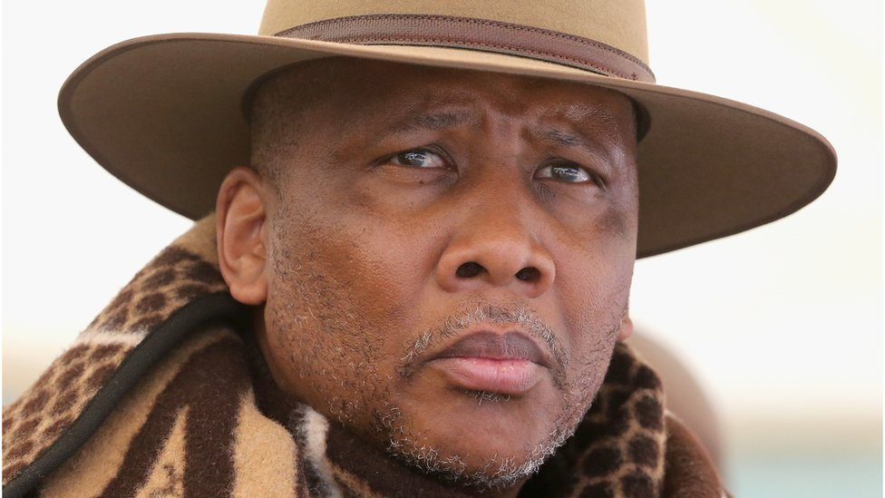image copyrightGetty Images

King Letsie III succeeded his father, King Moshoeshoe II, who was dethroned in 1990.

Five years later, after the return to civilian government and amid political instability, he abdicated and his father was reinstated as monarch.

Letsie III was restored as king in 1996 after his father died in a car accident. The monarch has no legislative or executive powers.

**Prime minister: Moeketsi Majoro**

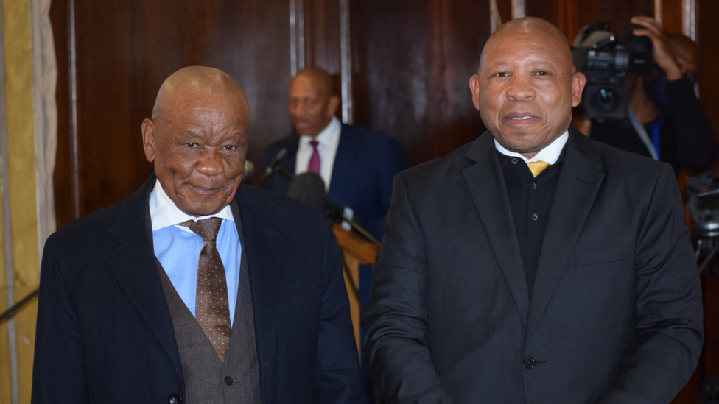image copyrightGetty Images

image captionMr Majoro (right), with his predecessor Thomas Thabane

Finance Minister Majoro Thomas took over as prime minister in May 2020, after the resignation of veteran leader Thomas Thabane, who was named as a suspect in the murder of his own ex-wife.Mr Thabane's All Basotho Convention (ABC) had won early elections in June 2017, and continues to govern in coalition with three other parties.

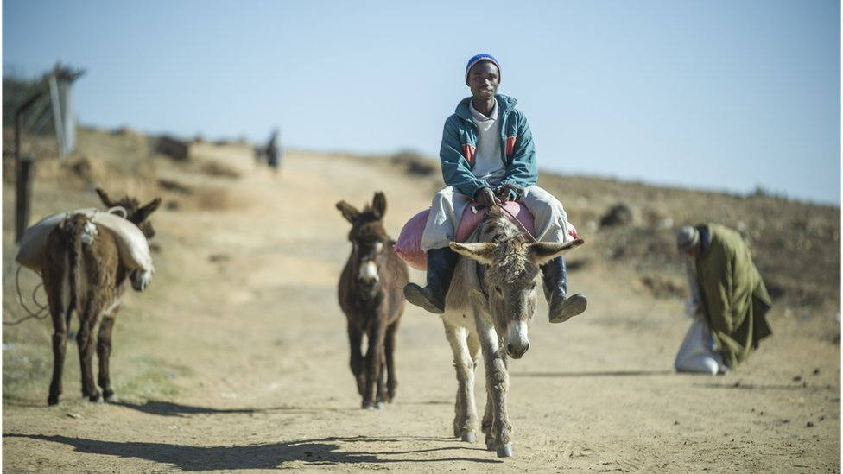image copyrightGetty Images

Radio is the most-popular medium. As well as domestic outlets, South African radio and TV stations can be received.

# Lesotho profile - Timeline

Published

14 May 2018

## A chronology of key events:

**1820s** - Basutoland founded by Moshoeshoe, who unites various groups to repel challenges from Zulus.

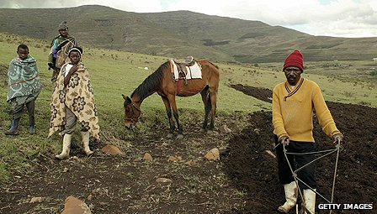image copyrightGetty Images

image captionConditions are tough for farmers in Lesotho, who have few resources

**1834** - Territorial encroachment by Boer trekkers starts decades of conflict.

**1860s** - Becomes a British protectorate.

**1871** - Annexed to the Cape Colony.

**1884** - Becomes a British colony after revolt against Cape Colonial rule. Paramount chiefs retain large degree of autonomy.

**1939-45** - World War II, with 20,000 Sotho serving in the British forces.

**1950s** - Political parties emerge, press for independence.

## Independence

**1966** - Independence as Kingdom of Lesotho, with Moshoeshoe II as king and Chief Leabua Jonathan (Basotho National Party) as prime minister.

**1970** - Oppostion Basutoland Congress Party leads in polls but Chief Jonathan suspends constitution, sends king into temporary exile.

**1986** - South Africa blocks borders, demanding expulsion of anti-apartheid activists. Major-General Justin Lekhanya replaces Chief Jonathan in coup.

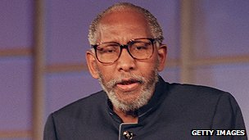image copyrightGetty Images

image captionKing Moshoeshoe II, pictured in 1995

**1990** - King Moshoeshoe II goes into exile. His son is sworn in as Letsie III.

**1991** - General Lekhanya forced out by Colonel Elias Tutsoane Ramaema, who lifts ban on political activity.

**1993** - Basutoland Congress Party comes to power in elections.

**1994** - Fighting among rival army factions.

## King Letsie III restored

**1995-1996** - Moshoeshoe II restored to throne, but dies in a car crash. Letsie III restored as king.

**1998** - Lesotho Congress of Democrats (LCD) wins general elections, Pakalitha Mosisili becomes prime minister. South African Development Community (SADC) sends troops to help restore order after opposition riots.

## Mosisili's second term

**2002** June - Prime Minister Mosisili is sworn-in for a second five-year term.

**2004** February - Prime Minister Mosisili declares state of emergency, appeals for food aid. Aid officials say hundreds of thousands face shortages after three-year struggle against drought.

**2004** March - Official opening of first phase of multi-billion-dollar Lesotho Highlands Water Project, which supplies water to South Africa.

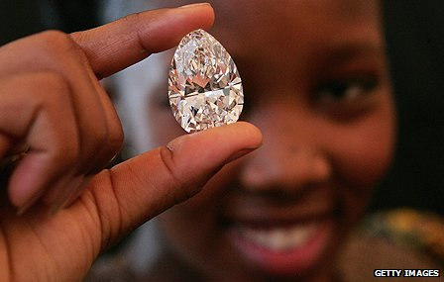image copyrightGetty Images

image captionDiamonds and water are Lesotho's main export earners. This stone was cut from 'Lesotho Promise', the world's 15th largest diamond

## Early elections

**2007** February - Ruling LCD wins early parliamentary elections, taking 61 of 80 constituencies; leader of the opposition All Basotho Convention (ABC) challenges the outcome.

**2007** July - State of emergency declared as Lesotho experiences its most severe drought in 30 years.

**2012** May - ABC's Thomas Thabane becomes prime minister following elections.

**2014** August - Prime Minister Thabane flees to South Africa, accusing the military of trying to overthrow him.

**2015** February - Pakalitha Mosisili becomes prime minister at the head of a coalition formed after early elections.

**2017** June - Prime Minister Mosisili loses early elections, Thomas Thabane returns to power.

**2017** September - The head of the armed forces, Khoantle Mots'omots'o, is shot dead. A multinational security force is deployed to ease tensions.